Implement fixes and demonstrate that the same attacks no longer succeed

The fixes I made are mostly what I told the common fixes are for these vulnerabilities

For SQL injection I used placeholders so that the input received is a treated as data and not as a query and also limited the input size to 50 for further strengthening this dosnt prevent injection in anyway just so that some lengthy string dosnt wast the cpu power (catching exception so that nothing important get sent back to the user)
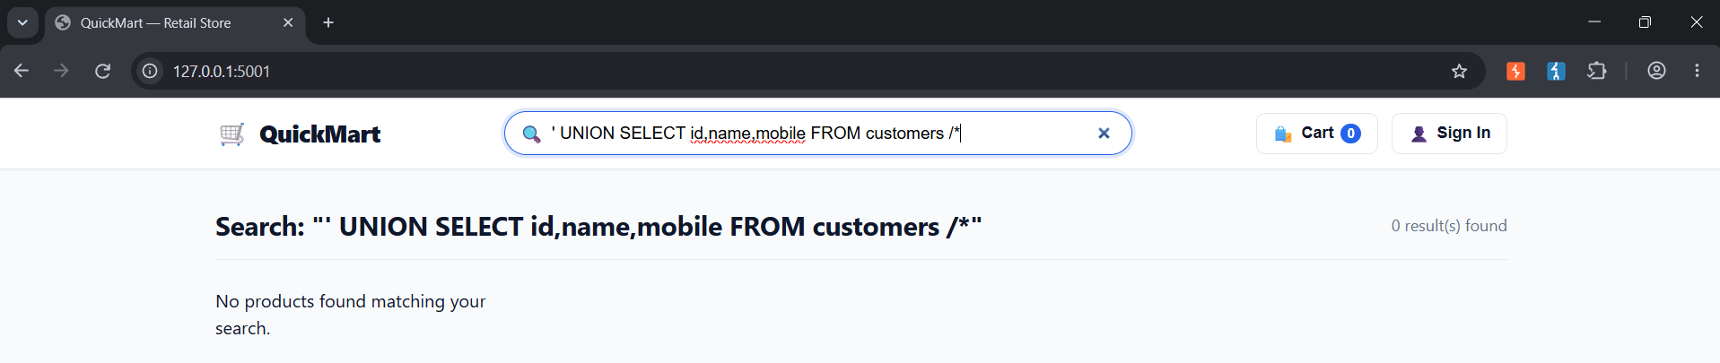

Our next and most important concern was Auth failure
for this I used Scrypt to make them salted hashes like I suggested, now all the passwords so even if it gets returned back somehow they cant make sense of it even if the hash is known like MD5 is now decryptable and using salts makes sure that no two hashes even if same will produce the same hash .
I changed the passwords to a stronger one so the password shouldn’t be in very high in the dictionary.
I also added another layer for admins alone (was inspired while doing this by github’s auth mechanism) they will need to provide uniquely generated key from authenticator.
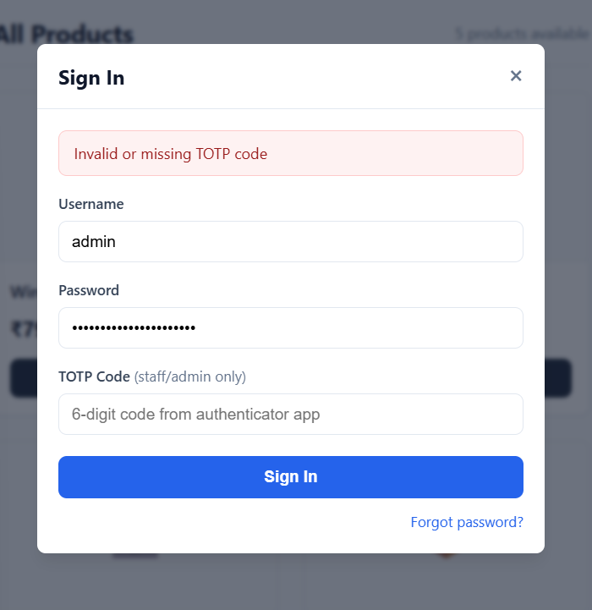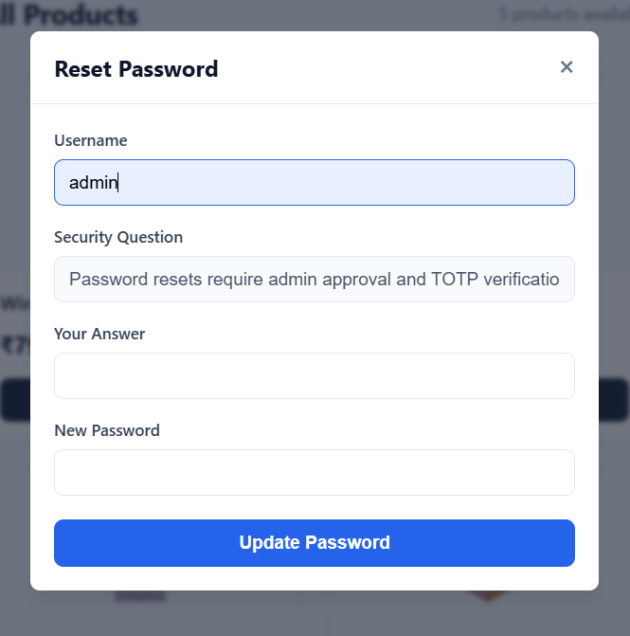

So all four cases I found(I wanted the website to have) are now secure.

For Broken Access Control:
I am only allowing admin to see cust details
With customer and employee login:
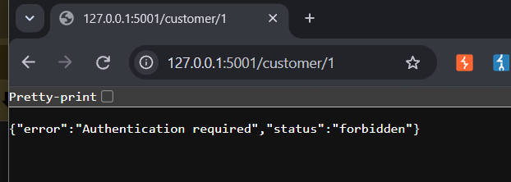
Loged in as admin:
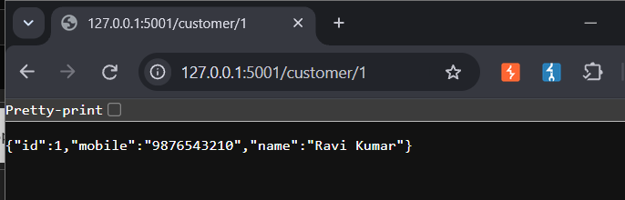
This is done using session id so a user can see his own details
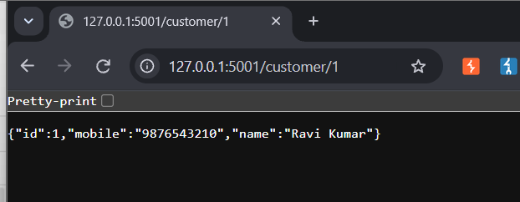
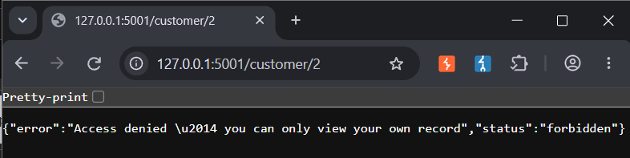

So user cant upgrade to admin privilege, and the server also checks for user

Now for the only remaining Vulnerability Mishandling of Exceptional Conditions
For this I turned off the debug mode from server and also added a lot of exception (also a global exception to catch any if missed) so now most of the exceptions should give 400 bad request error and not 500 internal server error(only if server failed and stuff 500 is returned and this dosnt send any data back to the user anyway). Also added limiters to prevent server overload such as limited the server to accept only 20(20 is the mean amount of request a server gets in a min) and by limiting the max storage to 1000. So there shouldn’t be any way to deep fry the server and making it return and code.
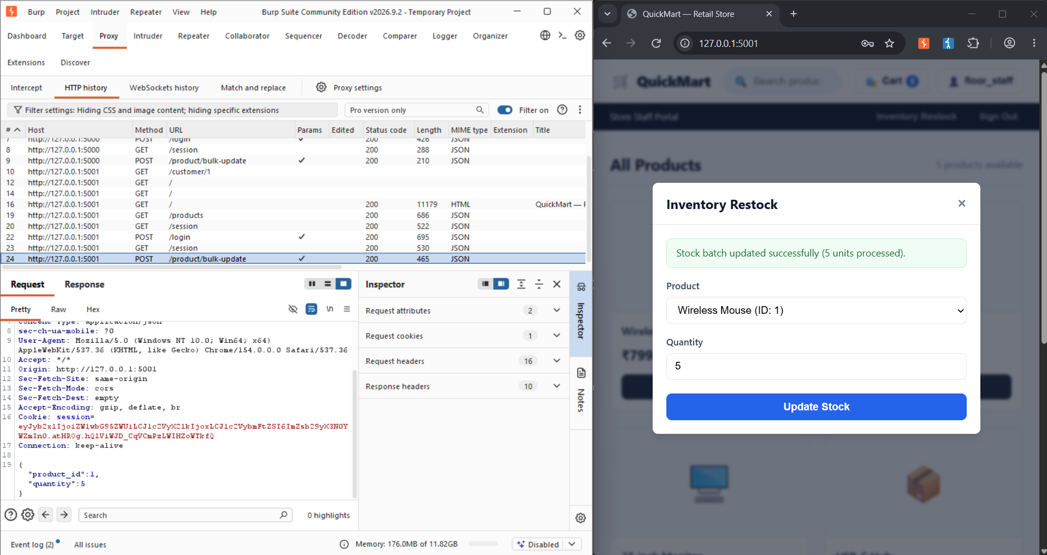
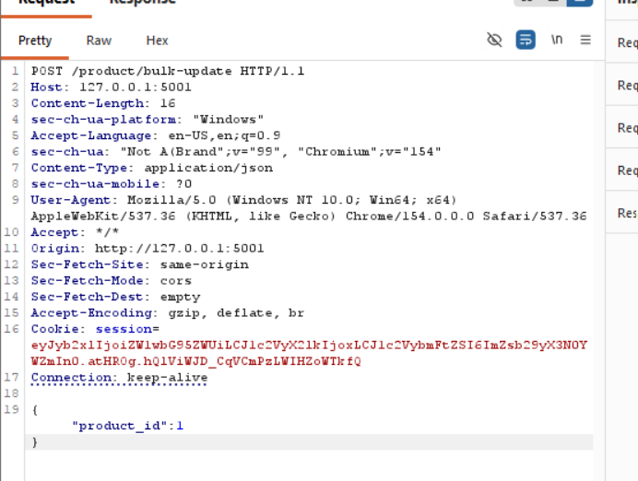
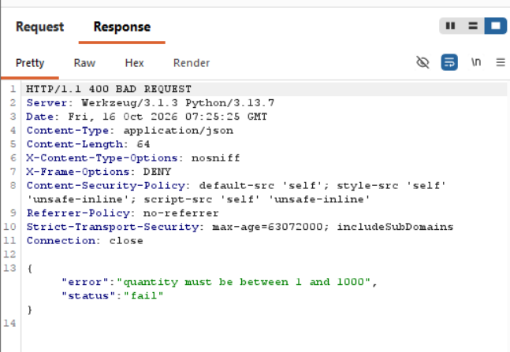

Also the cookies are now hashed and SESSION_COOKIE_SECURE = True so that cookies now are never sent over plain HTTP connections.

For the assumptions:
Well we assume that all necessary network preventive methods such as an firewall, IDS or IPS are present. Cause nothing against them is implemented and if a DoS attack occurs then nothing can be done.
There is no log system on who did what and when
Accounts can have 5 incorrect passwords but I didn’t check If these requests are coming from the same IP so if an account get locked then its locked through out.
Not TLS handshake so the session cookies are just signed message by flask which is not so secure this dosnt make it invicible the cookies are only tamper proof.

